Project Development Phase
Model Performance Test

Date | 10 February 2025
Team ID | LTVIP2025TMID38720
Project Name | TrafficTelligence: Advanced Traffic Volume Estimation with Machine Learning
Maximum Marks | 10 Marks

Model Performance Testing:
Project team shall fill the following information in model performance testing template.
S.No. | Parameter | Values | Screenshot
 | Metrics | Regression Model:  • MAE: 211.90  • RMSE: 371.16  • R² Score: 0.9653  Classification Model:  Not Applicable | 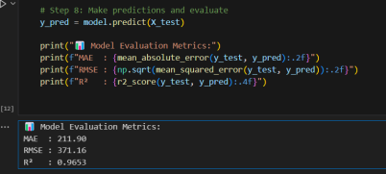
 | Tune the Model | Hyperparameter Tuning:  ❌ No hyperparameter tuning was applied.  Model Used:  • RandomForestRegressor with default settings.  • Used train_test_split(test_size=0.2) from sklearn.model_selection  • Data was split into training (80%) and testing (20%) sets | 